Student Name:

Student ID:

7PAM2000 Applied Data Science 1

Assignment 1: Visualisation

Contents

Dataset 2

Line Plot Graph 2

KDE abbreviation plot graph 3

Box plot 3

# Dataset

<https://data.worldbank.org/topic/climate-change>

# Line Plot Graph

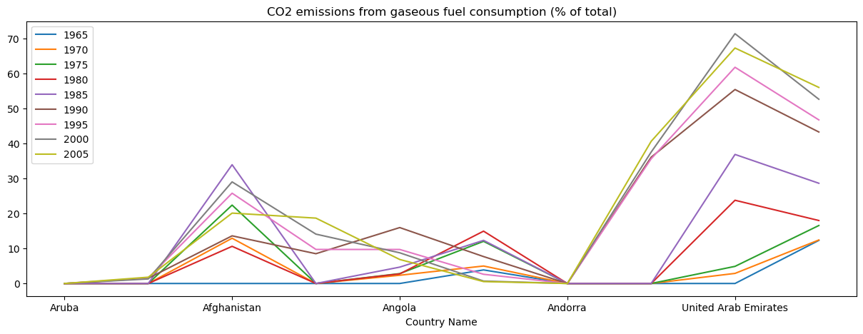

Figure Graphical representation of Line plot of CO2 emissions from gaseous fuel consumption.

After the proper preprocessing of the dataset where there is performed of dropping unused data, getting the information of data, and replacing the null values with zero, then the line plot function generates the above result of the graphical representation of the CO2 emissions from gaseous fuel consumption using the line plot graph where there is illustrated that among a total of five countries the United Arab Emirates has the high percentage because this company has a high mining sector than those other countries. This result is previewed with the proper implementation of the line plot function in the selected dataset data of different years, and later it is called, so the above result is viewed.

# KDE abbreviation plot graph

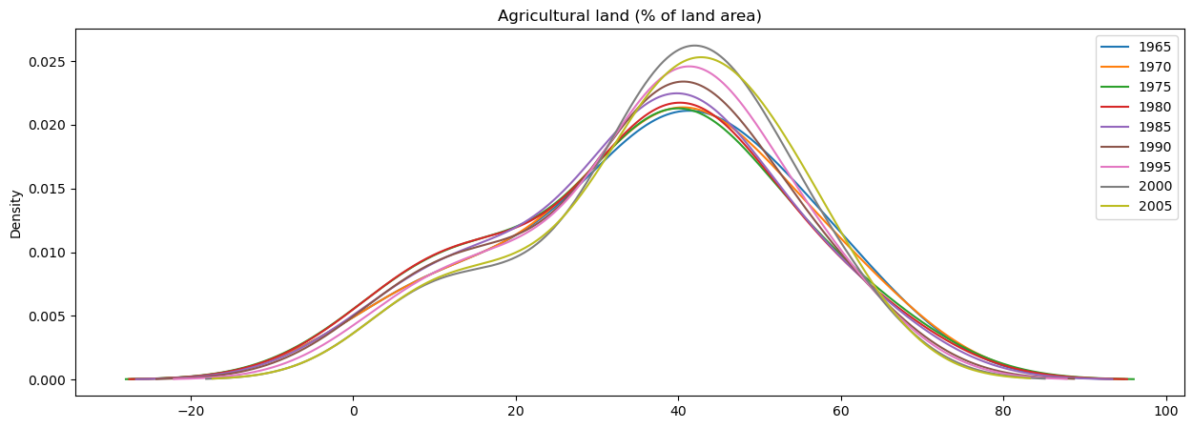

Figure Kde abbreviation plot graphical representation of Agricultural land.

There is an illustration of the agricultural land which acts as a carbon sink (which absorbs carbon dioxide and mitigates climate change) graphical representation in the form of a Kde plot graph. This resulted in the proper definition of the kdeplot function in the selected dataset, where there is taken of head 10 samples of data and plotted data from different years using the group of 15 countries. Then with the proper call of the KDE plot function using python programming, is resulted where there can be seen that an average of 40% of 15 countries have a high density in different years. The grouped 15 countries are Aruba, Africa Eastern and Southern Afghanistan, Africa Western and Central, Angola, Albania, Andorra, Arab World, United Arab Emirates, Argentina, Armenia, American Samoa, Antigua and Barbuda, Australia, and Austria.

# Box plot

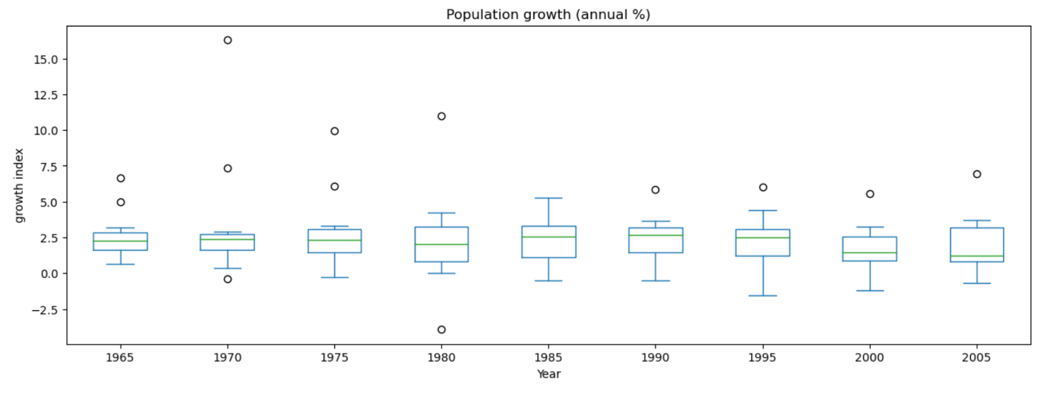

Figure Population growth graphical representation through Box plot

The above, there is illustrated the proper graphical representation of the population growth of the 15 grouped countries with the different year's data from the selected dataset, which is represented in the form of a box plot graph. For this result, there is implemented proper function where there is dropped un-used column from the dataset with the indicator name index of different countries from the dataset, and then the top 15 countries of the dataset are grouped based on the country name, and the data are plotted as per the different years' population, and then boxplot function is called for the result. In the above result, there can be seen that during the 1970 year, there was a high population growth annually of all the average countries, which have a growth rate of more than 15%. The grouped 15 countries are Aruba, Africa Eastern and Southern Afghanistan, Africa Western and Central, Angola, Albania, Andorra, Arab World, United Arab Emirates, Argentina, Armenia, American Samoa, Antigua and Barbuda, Australia, and Austria.